Chapter 1
INTRODUCTION
Guardian Care is a web-based elderly health monitoring and assistance system designed to support guardians, doctors, and elderly users through a connected digital care platform. The project focuses on real-time health observation, medicine reminders, emergency alerts, daily activity monitoring, and doctor review features. Elderly people often require continuous support for medication, routine activities, vital signs, and emergency situations. In many families, guardians may not always be physically present with the elder, which creates a need for a reliable remote monitoring system.
The Guardian Care system provides a centralized platform where guardians can monitor the elder's live health status, manage reminders, receive alerts, maintain emergency contacts, and view logs of important activities. The application includes a watch simulator that represents a wearable device interface. This watch view displays heart rate, oxygen saturation, steps, medicine reminders, and multilingual voice assistance. The doctor portal allows medical professionals to review patient vitals, medication adherence, clinical notes, and recent health summaries.
The project is implemented using React, TypeScript, Tailwind CSS, Zustand state management, Re-charts for visualization, React Router for navigation, and a lightweight Node.js backend server for storing medication and alarm data. The frontend presents role-based interfaces such as landing page, login page, dashboard, guardian portal, elder detail page, settings page, and doctor portal. The backend exposes REST APIs for dashboard data, medication records, alarms, and health checks. Demo vitals data is loaded from CSV and displayed using charts to simulate continuous monitoring.
Guardian Care is especially useful for families caring for senior citizens who may suffer from chronic diseases such as diabetes, hypertension, cardiac conditions, or age-related mobility issues. The system reduces dependency on manual reminders by supporting medication schedules, food reminders, activity reminders, appointment reminders, SOS alerts, fall detection simulation, watch notifications, and emergency contact management. It also supports regional language interaction through multilingual interface files and voice assistant features, making the system more accessible for Indian elderly users.

1.1 Motivation
The motivation behind Guardian Care is the increasing need for digital elder care solutions. Many elderly people live alone or stay away from their children due to work, education, or family commitments. In such situations, missing medicines, delayed emergency response, abnormal vitals, and lack of regular doctor communication can create serious health risks. Traditional care methods depend heavily on phone calls, manual observation, and memory-based medication management. These methods are not always reliable.
Guardian Care aims to solve this problem by creating a single platform for monitoring, reminders, and communication. The project is motivated by the following needs:
- To help guardians remotely monitor elders.
- To reduce missed medicines through scheduled reminders.
- To provide emergency SOS support with contact information.
- To support doctors with organized health summaries.
- To improve elder safety using simulated wearable monitoring.
- To support multilingual interaction for ease of use.

1.2 Objectives
The main objectives of this project are:
- To design and develop a responsive web application for elder care monitoring.
- To provide live vitals visualization such as heart rate, blood pressure, SpO2, stress, hydration, and body temperature.
- To implement reminder management for medicines, food, activities, and doctor appointments.
- To provide SOS and emergency alert features for critical situations.
- To create a doctor portal for viewing patient information, vitals trends, medication adherence, and clinical notes.
- To simulate a smartwatch interface for elder-side reminders and health status.
- To support multilingual interaction through language files and voice assistant logic.
- To store medication and alarm data using a lightweight backend API.

1.3 Scope of the Project
The scope of Guardian Care includes guardian login, guardian profile management, elder profile management, emergency contact setup, live feed dashboard, reminders, alerts, logs, SOS, smart TV support, watch simulator, doctor portal, and backend APIs. The system is built as a prototype and can be extended into a real healthcare product by integrating actual wearable devices, cloud database, authentication, SMS/call notification gateways, and medical-grade IoT sensors.

1.4 Summary
Guardian Care is a healthcare assistance system that improves elderly care by combining monitoring, reminders, alerts, doctor support, and wearable simulation. It helps guardians observe elders remotely and respond quickly to health-related events. The system is designed with modern web technologies and can be expanded for real-time IoT integration in future versions.

Chapter 2

LITERATURE SURVEY
The literature survey focuses on existing research and technologies related to elderly health monitoring, IoT-based healthcare systems, wearable devices, emergency alert systems, medication reminder applications, and telemedicine platforms. With the growth of smart devices and web technologies, healthcare monitoring has moved from hospital-only systems to home-based and remote patient monitoring systems.
The paper “The Internet of Things for Health Care: A Comprehensive Survey” discusses how IoT technology is transforming healthcare through connected sensors, wearable devices, cloud computing, and real-time patient monitoring. It explains how healthcare systems can continuously collect patient data such as heart rate, temperature, oxygen level, and emergency conditions using smart devices. The study also highlights challenges like security, privacy, lack of real-time emergency response, and difficulty in integrating multiple healthcare services into a single platform. The major gap identified in this work is the absence of a complete patient-centered emergency support system with intelligent monitoring and caregiver communication. In the G-Care project, this gap is addressed by integrating real-time health monitoring, emergency alert mechanisms, and caregiver notifications into one smart healthcare solution for elderly safety and continuous assistance. [1]
The paper “A Survey on Wearable Sensor-Based Systems for Health Monitoring and Prognosis” focuses on wearable sensor-based healthcare systems used for monitoring patients remotely. It explains how wearable devices can track physiological signals and help doctors observe patients without requiring hospital visits. The paper mainly concentrates on sensing technologies and health prognosis but gives less importance to intelligent interaction, medication support, and elderly-friendly communication systems. A significant limitation found in the paper is the lack of user-assistance features for older adults who may struggle with technology usage. The G-Care project improves this by implementing smart reminder systems, automated alerts, and simplified assistance features that make healthcare monitoring easier and more practical for elderly users in daily life. [2]
The paper “Wearable Sensors for Remote Health Monitoring” explains the use of wearable sensors in remote healthcare monitoring and describes different biosensors used for tracking human activities and medical conditions. It highlights benefits such as mobility, continuous observation, and wireless communication. However, the paper mainly emphasizes monitoring and data collection while lacking predictive emergency handling and integrated fall detection support. Another limitation is the insufficient focus on combining multiple healthcare services into one unified framework. The G-Care project fills this gap by combining wearable monitoring, emergency response, and intelligent fall detection into a single healthcare management system that improves safety and immediate medical attention for users. [3]
The paper “Photoplethysmography and its Application in Clinical Physiological Measurement” studies photoplethysmography (PPG) and its role in measuring physiological parameters like heart rate and blood circulation. The research mainly focuses on the technical and clinical aspects of PPG signal analysis for medical measurements. Although the paper provides detailed insights into signal processing and monitoring techniques, it does not address practical implementation in smart healthcare environments for elderly care or emergency assistance. The identified gap is the lack of integration between physiological sensing and automated healthcare actions. The G-Care project addresses this limitation by using sensor-based monitoring together with automatic alert generation and healthcare assistance features to provide real-time support during abnormal health conditions. [4]
The paper “Challenges, Issues and Trends in Fall Detection Systems” discusses various fall detection systems and analyzes challenges faced in detecting falls accurately using wearable and external sensors. It highlights issues such as false alarms, poor accuracy, limited real-time response, and difficulties in providing immediate medical assistance after fall detection. The study mainly reviews detection approaches but lacks an integrated solution for caregiver communication and intelligent emergency handling. The G-Care project overcomes these limitations by implementing a smart fall detection mechanism along with instant notifications and emergency response support, ensuring faster assistance and improved elderly safety during critical situations. [5]

Chapter 3
PROBLEM STATEMENT
Elderly people often require continuous health monitoring, timely medication, routine care, and emergency assistance. Guardians and doctors may not always be physically present to monitor the elder. Existing solutions are often fragmented, where one application handles medication reminders, another tracks vitals, and another provides emergency contact support. This creates inconvenience and increases the risk of missed health events
The problem is to design and develop an integrated elder care system that allows guardians to remotely monitor elders, manage medicine and routine reminders, track vitals, receive emergency alerts, maintain logs, and support doctor review from a single digital platform.

3.1 Existing System
In the existing manual system, guardians usually depend on phone calls, physical visits, handwritten medicine schedules, and verbal updates from the elder. Doctors receive updates only during appointments or when a guardian manually reports a problem. This causes delay in identifying health risks.
- Limitations of the existing system:
- Medicine reminders are manual and can be forgotten.
- Guardians cannot continuously monitor health status.
- Emergency response may be delayed.
- Doctor review depends on incomplete information.
- Health trends are difficult to visualize.
- Elder activity and routine logs are not maintained properly.

3.2 Proposed System Design
The proposed system provides a web-based platform with separate interfaces for guardians and doctors. Guardians can manage reminders, view vitals, trigger SOS, review alerts, and maintain elder details. Doctors can view patient data, vitals trends, medication adherence, and clinical notes. The watch simulator represents the elder-side wearable interface.

3.3 Data Flow Diagram
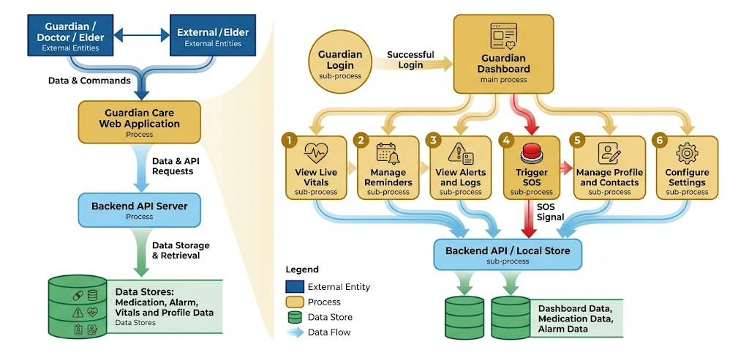Figure 3.1 Data Flow Diagram
3.4 Use Case Diagram
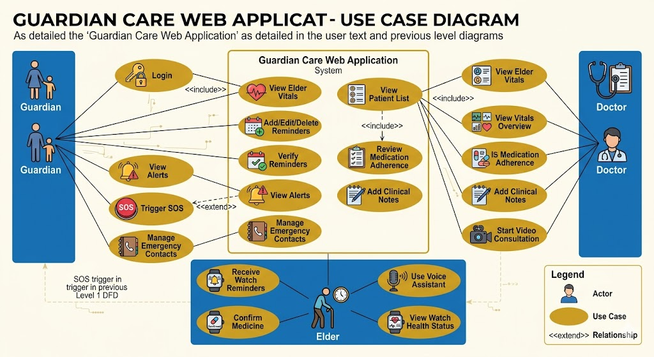Figure 3.2 Use Case Diagram
Chapter 4
OBJECTIVES
The objectives of Guardian Care are:
- To develop a user-friendly elder care monitoring system.
- To provide a guardian dashboard for live health updates.
- To display vitals such as heart rate, blood pressure, SpO2, hydration, stress, and temperature.
- To support reminders for medication, food, activity, and doctor appointments.
- To provide emergency SOS functionality.
- To maintain alerts and daily logs for health-related events.
- To provide a doctor portal for patient monitoring and notes.
- To simulate smartwatch-based monitoring and reminder confirmation.
- To provide multilingual support for improved accessibility.
- To build a scalable foundation for future IoT and healthcare integration.

Chapter 5
PROJECT DESIGN
Guardian Care follows a modular client-server architecture. The frontend is built using React and TypeScript. The backend is built using Node.js HTTP server. The application uses local state management through Zustand and data fetching through React Query. The user interface is styled using Tailwind CSS and component-based UI elements.

5.1 System Architecture
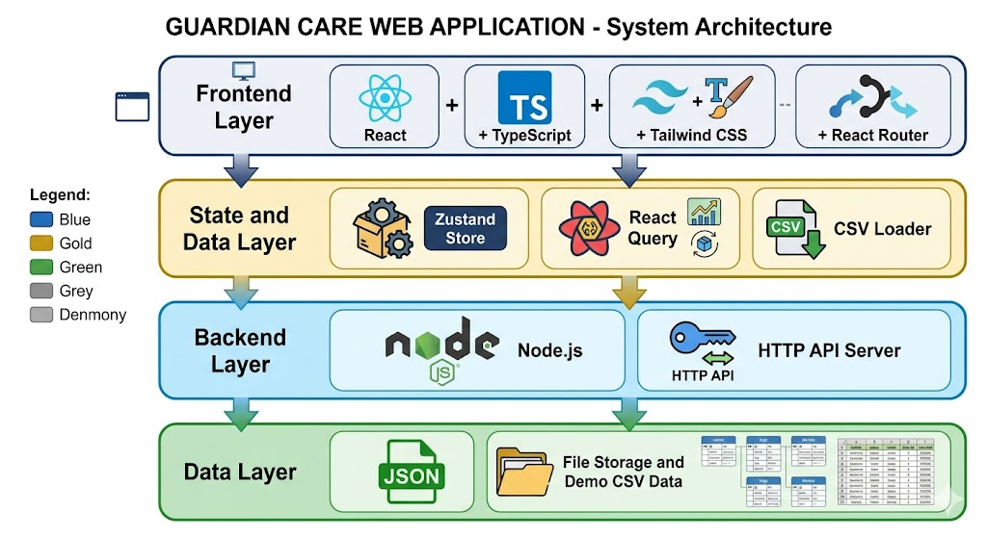Figure 5.1 System Architecture

5.2 Main Modules
- Landing and Login Module: Provides entry point and login flow.
- Guardian Dashboard Module: Provides feed, logs, alerts, reminders, SOS, and smart TV tabs.
- Reminder Module: Allows adding and managing medication, food, activity, and appointment reminders.
- SOS Module: Sends emergency alert and displays emergency contact details.
- Watch Simulator Module: Simulates wearable device view and reminder interaction.
- Doctor Portal Module: Displays patient vitals, medication adherence, summaries, and clinical notes.
- Backend API Module: Stores and retrieves medications and alarms.
- Localization Module: Supports English, Hindi, Kannada, and Tamil language files.

5.3 Database Design
The prototype uses JSON file storage. Main data entities are:
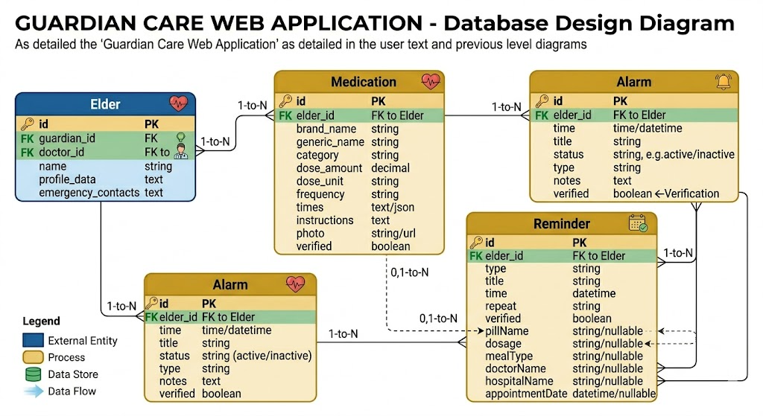Figure 5.2 Database Design

Chapter 6
METHODOLOGY
The methodology used in Guardian Care is component-based web application development. The system is divided into independent modules that communicate through routing, shared state, API calls, and reusable components.

6.1 Development Methodology
- Requirement analysis was performed to identify elder care problems.
- Modules such as guardian dashboard, doctor portal, reminders, SOS, and watch simulator were planned.
- React components were created for each functional area.
- State management was implemented using Zustand.
- Backend APIs were created using Node.js.
- Demo vitals data was loaded and visualized using charts.
- UI was styled using Tailwind CSS and reusable components.
- The application was tested using build and runtime checks.

6.2 Reminder Algorithm
```text
Start
Input reminder details
Select reminder type
Set time and repeat option
Save reminder in store
Display reminder in dashboard
At scheduled time, show watch notification
If elder confirms, mark reminder as verified
If not confirmed, keep reminder pending or alert guardian
End
``

6.3 SOS Algorithm
```text
Start
Guardian clicks SOS button
Start countdown
If cancelled before countdown ends, stop SOS
Else create critical SOS alert
Play alert sound
Show emergency contacts
Notify guardian dashboard
End
```

6.4 Vitals Monitoring Method
The system loads vitals data from CSV and displays it in charts and cards. It simulates live updates by periodically changing values such as heart rate, blood pressure, SpO2, stress, hydration, breathing rate, and temperature. Values are compared against normal ranges and displayed using status colors.

Chapter 7
SOFTWARE AND HARDWARE REQUIREMENTS
7.1 Software Requirements
- Operating System: Windows 10/11, Linux, or macOS.
- Frontend Framework: React 18.
- Programming Language: TypeScript and JavaScript.
- Build Tool: Vite.
- Styling: Tailwind CSS.
- Backend: Node.js.
- Package Manager: npm.
- Chart Library: Recharts.
- Routing: React Router DOM.
- State Management: Zustand.
- UI Components: Radix UI and custom components.
- Browser: Google Chrome, Microsoft Edge, or Firefox.

7.2 Hardware Requirements
Minimum hardware requirements:
- Processor: Intel i3 or equivalent.
- RAM: 4 GB.
- Storage: 1 GB free space.
- Display: 1366 x 768 resolution.
- Network: Required for deployment and optional online features.
Recommended hardware requirements:
- Processor: Intel i5 or above.
- RAM: 8 GB or above.
- Storage: 5 GB free space.
- Display: Full HD resolution.
- Microphone: Required for voice assistant testing.

Chapter 8
IMPLEMENTATION
The Guardian Care project was implemented as a React and TypeScript web application with a Node.js backend. The main implementation includes routing, guardian dashboard, reminders, SOS alerts, watch simulator, doctor portal, backend APIs, charts, and local storage

8.1 Code Snippets

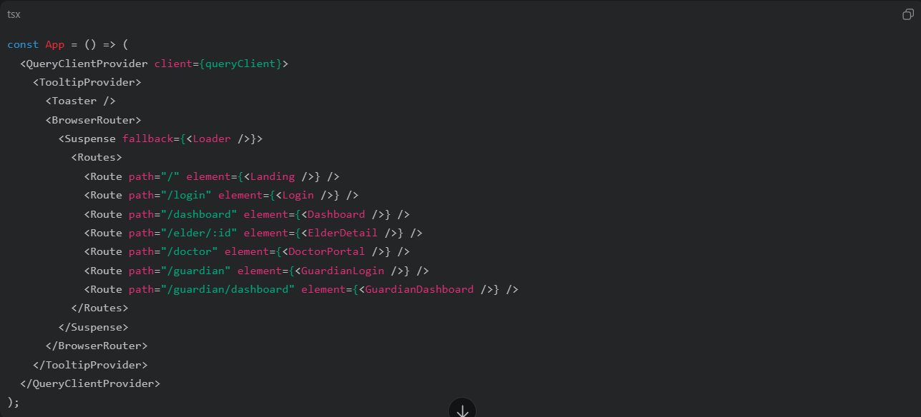
Figure 8.1.1 App Routing

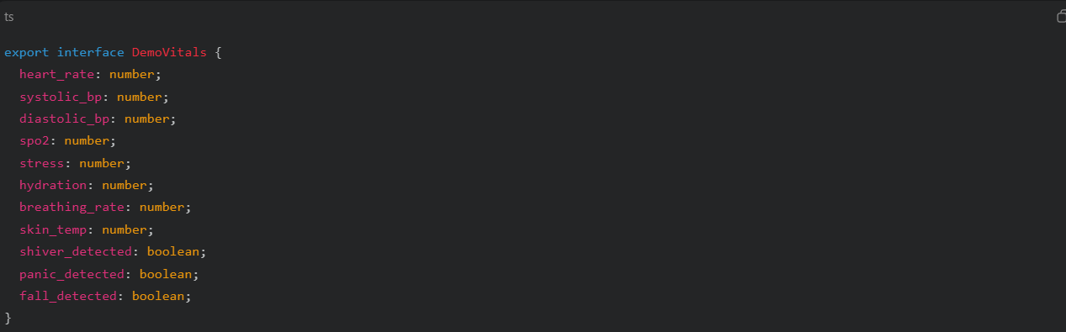
Figure 8.1.2 Elder Vitals Data Model

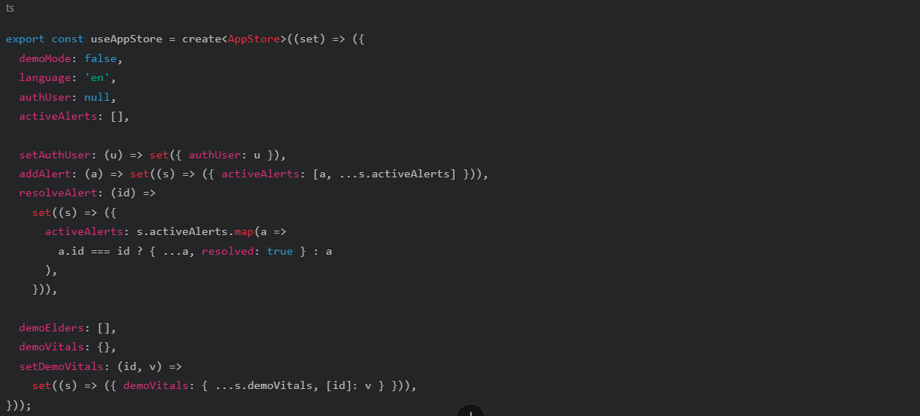
Figure 8.1.3 Global State Store

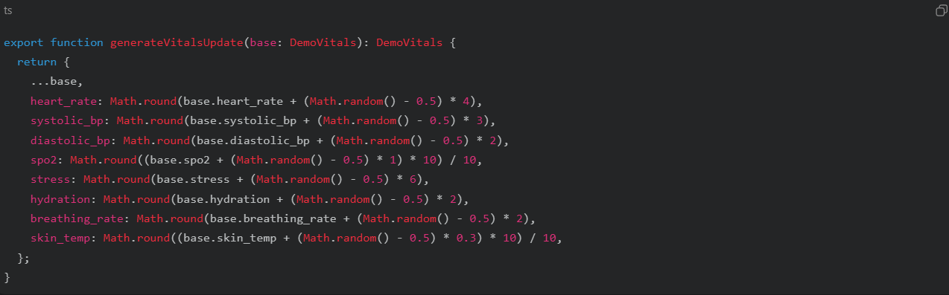
Figure 8.1.4 Vitals Simulation
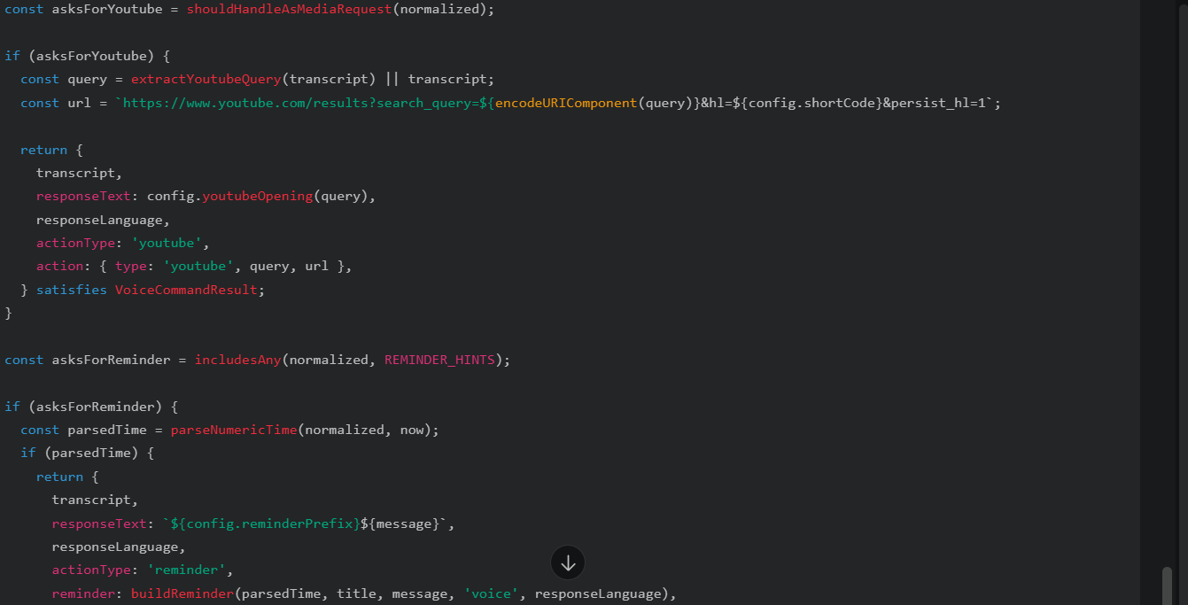Figure 8.1.5 Voice Command Processing

Chapter 9
OUTCOMES
9.1 Results
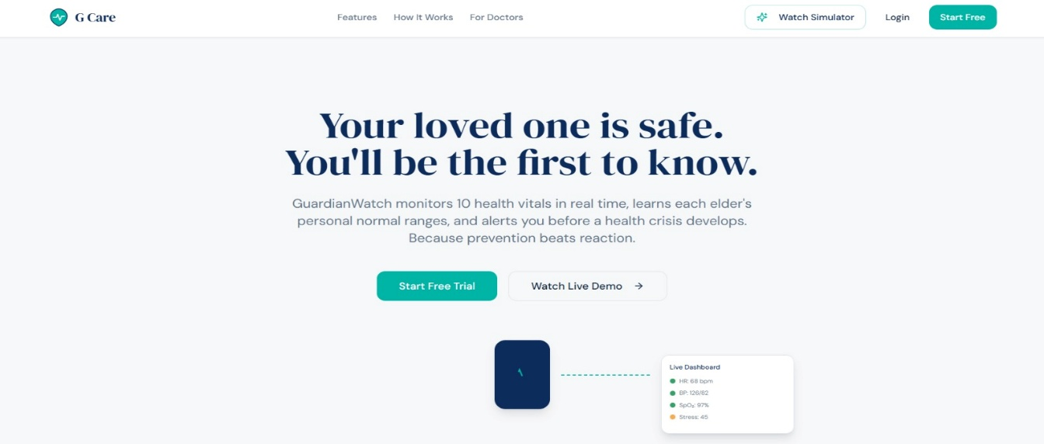Figure 9.1 Interface Design

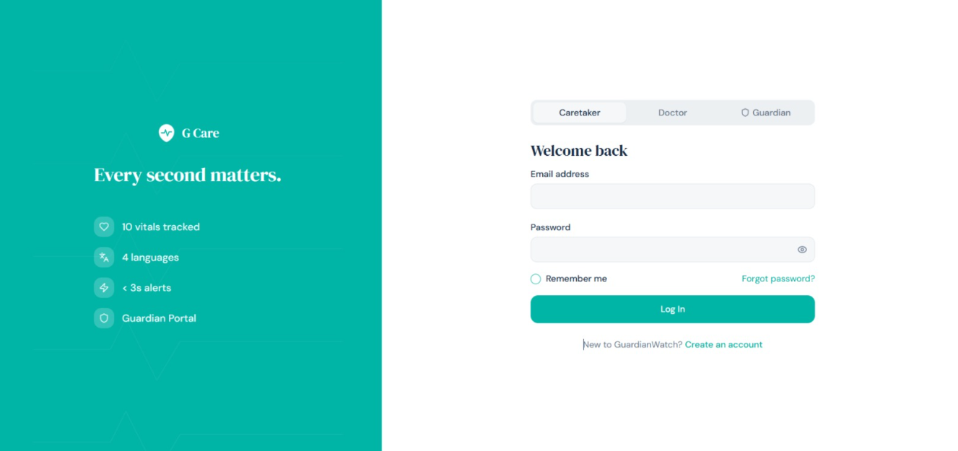Figure 9.2 Login Page
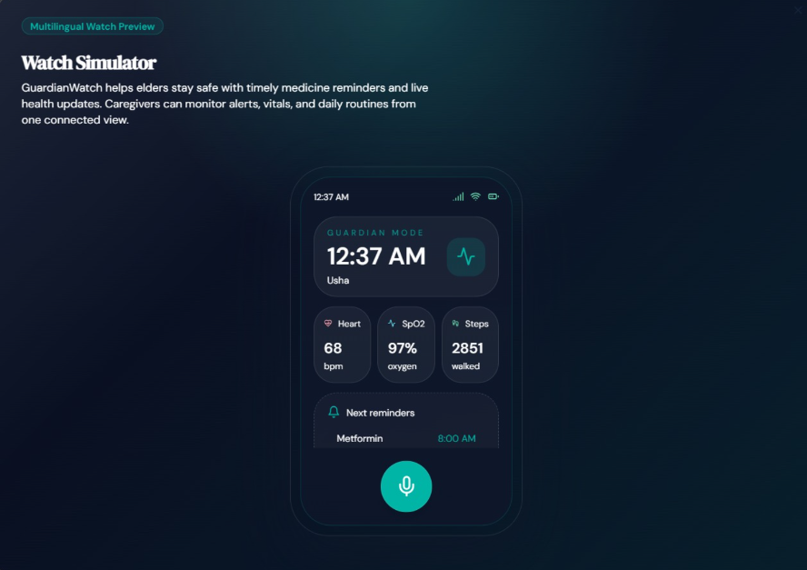Figure 9.3 Watch Interface

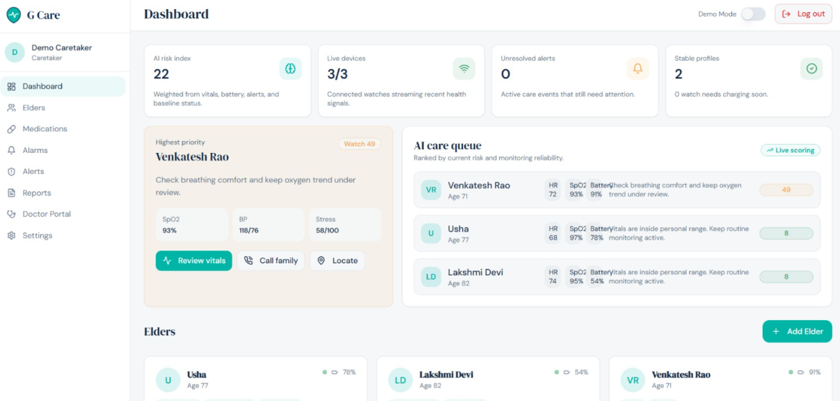Figure 9.4 Dashboard

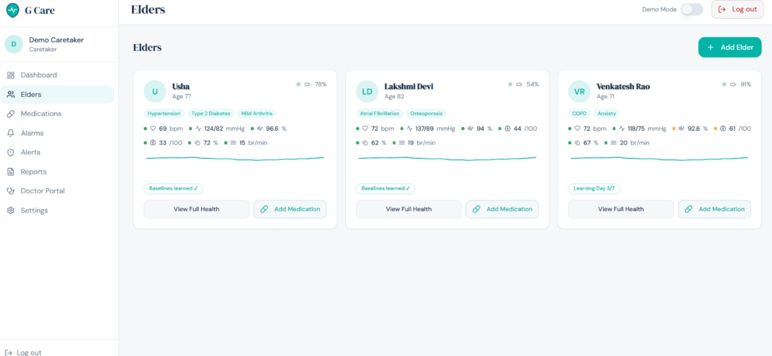Figure 9.5 Patient Interface

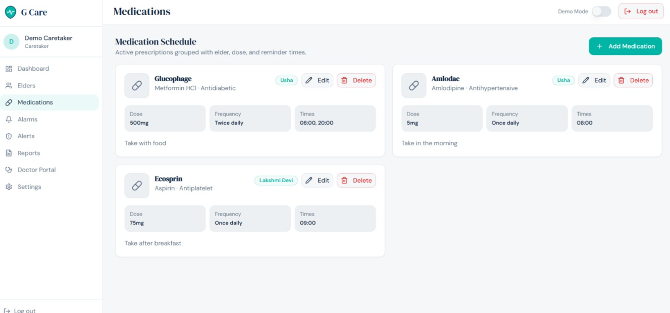Figure 9.6 Medications Page

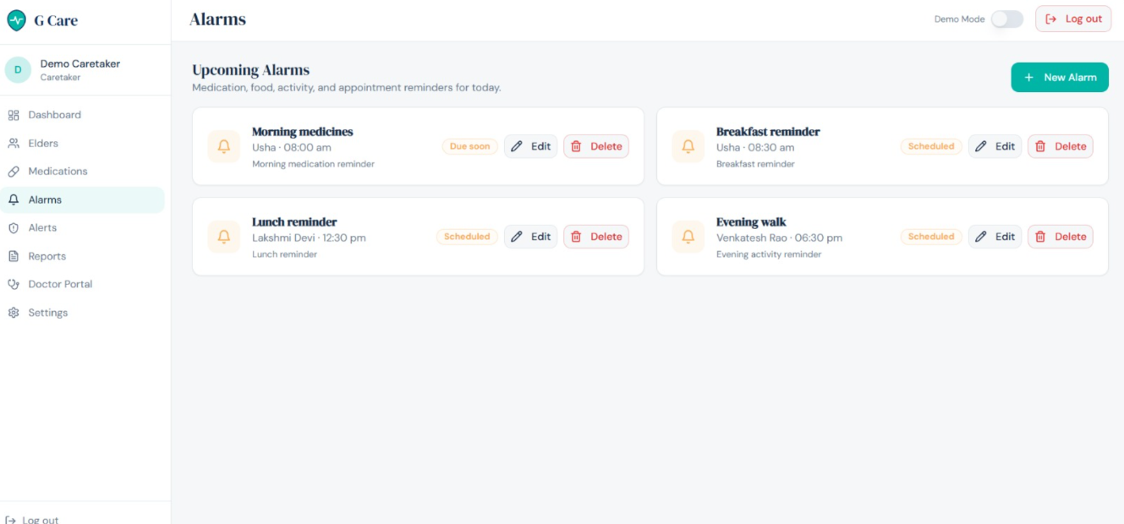Figure 9.7 Alarm Page

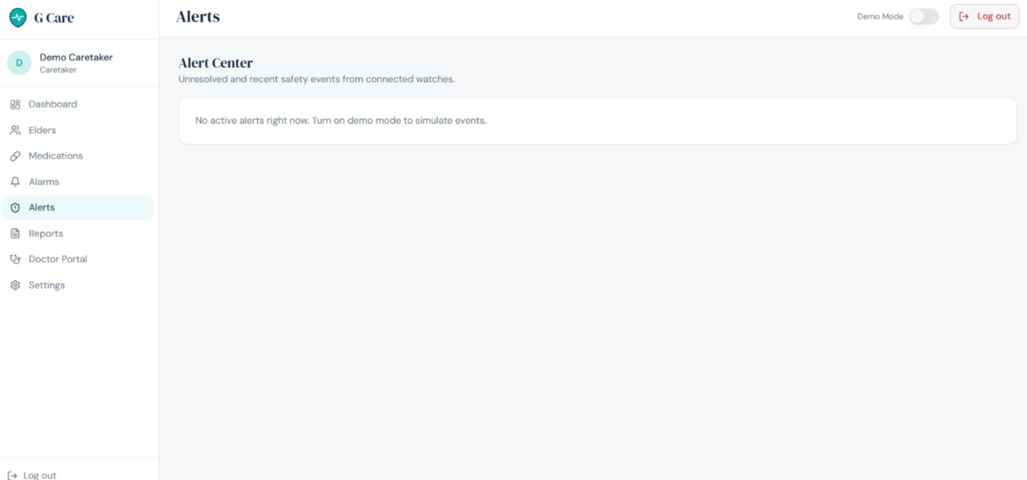Figure 9.8 Alerts Page

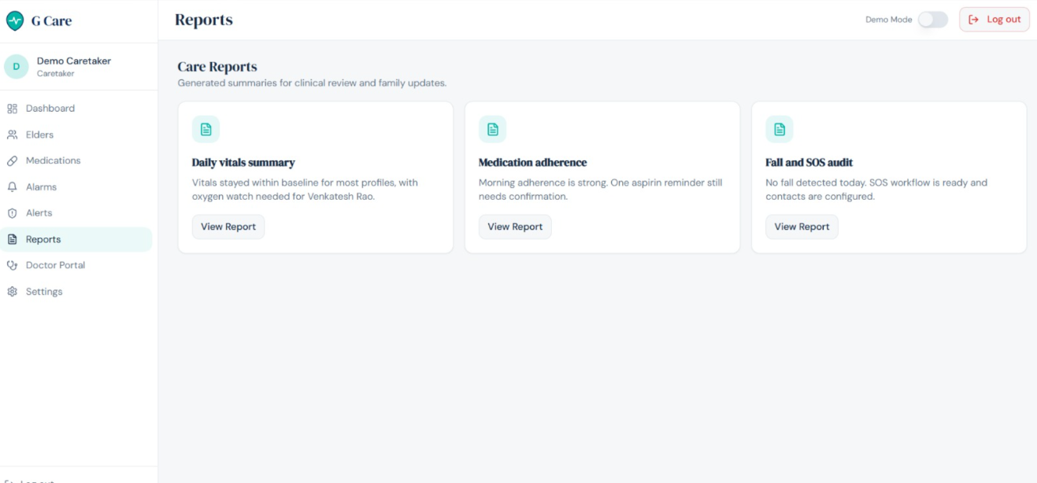Figure 9.9 Reports Page

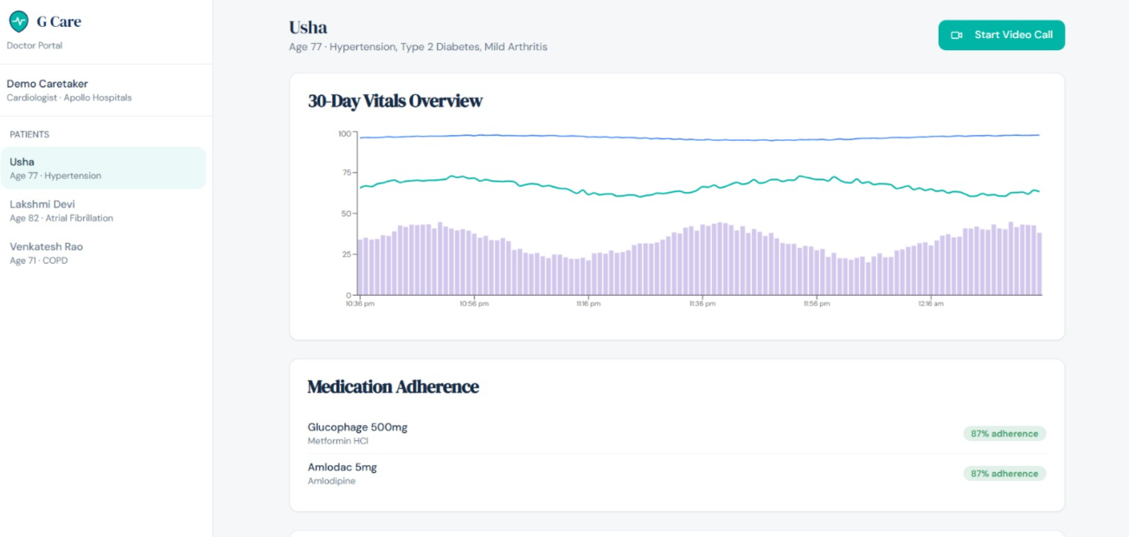Figure 9.10 Patient Overview

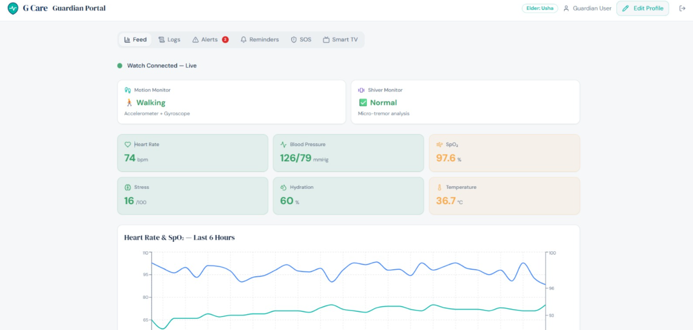Figure 9.11 Monitoring Dashboard

CONCLUSION
Guardian Care is a practical healthcare assistance system developed to improve elderly care through monitoring, reminders, emergency alerts, doctor support, and wearable simulation. The system addresses common problems faced by elders and guardians, such as missed medicines, delayed emergency response, lack of continuous monitoring, and incomplete communication with doctors. By combining guardian dashboard, doctor portal, SOS, reminders, vitals charts, and watch simulator, the project provides a complete prototype for remote elder care.
The project successfully demonstrates how modern web technologies can be used to create a useful healthcare monitoring solution. The modular architecture makes the application easy to maintain and extend. Although the current version uses demo data and a lightweight JSON backend, it can be expanded into a real-time healthcare system with IoT devices and cloud integration.
Future scope:
- Integration with real smartwatch or IoT wearable sensors.
- Cloud database integration using Firebase, MongoDB, or PostgreSQL.
- Real authentication for guardians, doctors, and elders.
- SMS, WhatsApp, email, and phone call emergency notifications.
- AI-based health risk prediction using historical vitals.
- Real-time video consultation integration.
- Hospital management system integration.
- Mobile application version for Android and iOS.
- Location tracking and geofencing for elders.
- Medical report generation and export as PDF.

REFERENCES
[1] S. M. R. Islam, D. Kwak, M. H. Kabir, M. Hossain, and K.-S. Kwak, “The Internet of Things for Health Care: A Comprehensive Survey,” *IEEE Access*, vol. 3, pp. 678–708, 2015, doi: [10.1109/ACCESS.2015.2437951](https://doi.org/10.1109/ACCESS.2015.2437951).
[2] A. Pantelopoulos and N. G. Bourbakis, “A Survey on Wearable Sensor-Based Systems for Health Monitoring and Prognosis,” *IEEE Transactions on Systems, Man, and Cybernetics, Part C: Applications and Reviews*, vol. 40, no. 1, pp. 1–12, Jan. 2010, doi: [10.1109/TSMCC.2009.2032660](https://doi.org/10.1109/TSMCC.2009.2032660).
[3] S. Majumder, T. Mondal, and M. J. Deen, “Wearable Sensors for Remote Health Monitoring,” *Sensors*, vol. 17, no. 1, Art. no. 130, Jan. 2017, doi: [10.3390/s17010130](https://doi.org/10.3390/s17010130).
[4] J. Allen, “Photoplethysmography and its application in clinical physiological measurement,” *Physiological Measurement*, vol. 28, no. 3, pp. R1–R39, Mar. 2007, doi: [10.1088/0967-3334/28/3/R01](https://doi.org/10.1088/0967-3334/28/3/R01).
[5] R. Igual, C. Medrano, and I. Plaza, “Challenges, Issues and Trends in Fall Detection Systems,” *BioMedical Engineering OnLine*, vol. 12, Art. no. 66, 2013, doi: [10.1186/1475-925X-12-66](https://doi.org/10.1186/1475-925X-12-66).
[6] A. K. Bourke, J. V. O’Brien, and G. M. Lyons, “Evaluation of a threshold-based tri-axial accelerometer fall detection algorithm,” *Gait & Posture*, vol. 26, no. 2, pp. 194–199, Jul. 2007, doi: [10.1016/j.gaitpost.2006.09.012](https://doi.org/10.1016/j.gaitpost.2006.09.012).
[7] Y. G. de Miguel, M. A. Labrador, and J. D. Posada, “Survey on Fall Detection and Fall Prevention Using Wearable and External Sensors,” *Sensors*, vol. 14, no. 10, pp. 19806–19842, Oct. 2014, doi: [10.3390/s141019806](https://doi.org/10.3390/s141019806).
[8] C. M. Goldstein *et al*., “Randomized controlled feasibility trial of two telemedicine medication reminder systems for older adults with heart failure,” *Journal of Telemedicine and Telecare*, vol. 20, no. 6, pp. 293–299, Sep. 2014, doi: [10.1177/1357633X14541039](https://doi.org/10.1177/1357633X14541039).
[9] N. K. Choudhry *et al*., “Effect of Reminder Devices on Medication Adherence: The REMIND Randomized Clinical Trial,” *JAMA Internal Medicine*, vol. 177, no. 5, pp. 624–631, May 2017, doi: [10.1001/jamainternmed.2016.9627](https://doi.org/10.1001/jamainternmed.2016.9627).
[10] H. Dai *et al*., “The effect of interactive reminders on medication adherence: A randomized trial,” *Preventive Medicine*, vol. 103, pp. 98–102, Oct. 2017, doi: [10.1016/j.ypmed.2017.07.019](https://doi.org/10.1016/j.ypmed.2017.07.019).
[11] J. Thakkar *et al*., “Mobile Telephone Text Messaging for Medication Adherence in Chronic Disease: A Meta-analysis,” *JAMA Internal Medicine*, vol. 176, no. 3, pp. 340–349, Mar. 2016, doi: [10.1001/jamainternmed.2015.7667](https://doi.org/10.1001/jamainternmed.2015.7667).
[12] P. Nallam, S. Bhandari, J. Sanders, and A. Martin-Hammond, “A Question of Access: Exploring the Perceived Benefits and Barriers of Intelligent Voice Assistants for Improving Access to Consumer Health Resources Among Low-Income Older Adults,” *Gerontology and Geriatric Medicine*, vol. 6, 2020, doi: [10.1177/2333721420985975](https://doi.org/10.1177/2333721420985975).
[13] E. T. Lifset *et al*., “Ascertaining Whether an Intelligent Voice Assistant Can Meet Older Adults’ Health-Related Needs in the Context of a Geriatrics 5Ms Framework,” *Gerontology and Geriatric Medicine*, vol. 9, 2023, doi: [10.1177/23337214231201138](https://doi.org/10.1177/23337214231201138).
[14] D. G. Morrow, H. C. Lane, and W. A. Rogers, “A Framework for Design of Conversational Agents to Support Health Self-Care for Older Adults,” *Human Factors*, vol. 63, no. 3, 2021, doi: [10.1177/0018720820964085](https://doi.org/10.1177/0018720820964085).

